How to Access the Fraud Prevention Training on iHASCO

Version | Date | Comments | Title
1.0 | 19/08/2025 | New document | Director Business Assurance & Risk

Overview
All staff are required to complete Fraud Prevention Training via an online platform ‘iHASCO’. Training is completed within the first two weeks of employment and refreshed on a three yearly basis thereafter.

How to access training
All staff should have received a welcome email from ‘no-reply@ihasco.co.uk’ which contains a link to access the online portal. To access this, click ‘Log in with one click’ in the green box.
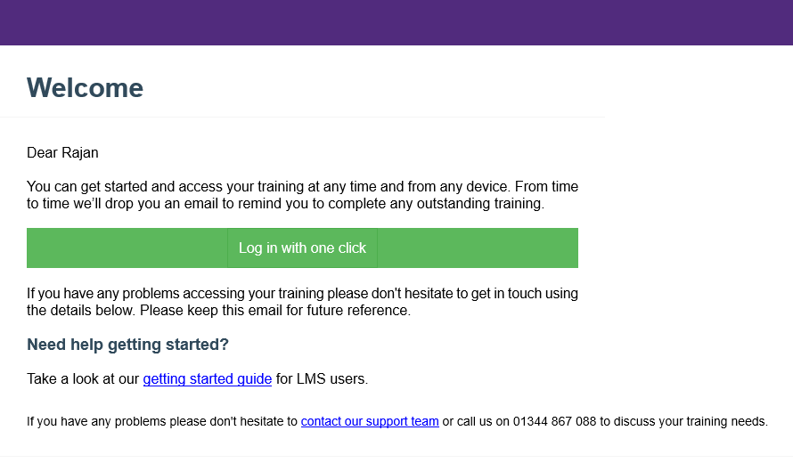

If you are unable to access the training using the above route, the training can also be accessed via LMS Login Area | iHasco or by inputting the following into your browser - https://www.ihasco.co.uk/login.
Next you will be required to input your NCG/college email address and then click ‘Send me a login link’ (see image below). You will shortly then receive an email as demonstrated above and will need to click ‘Log in with one click’.
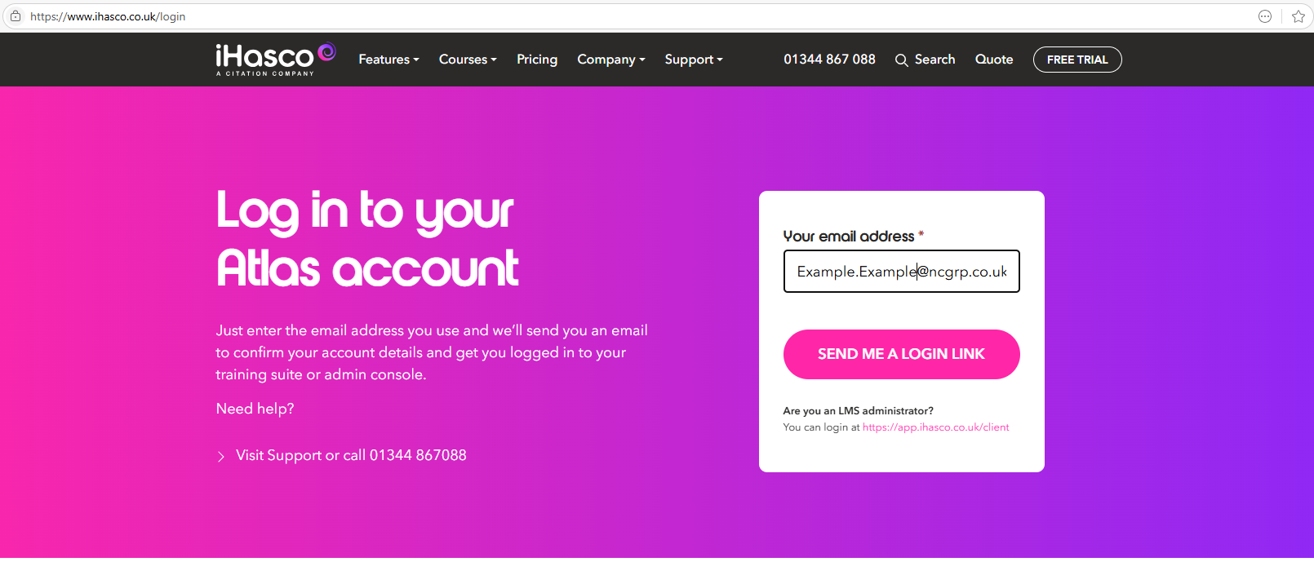

Once you have got access to the iHASCO online portal, click on the ‘Fraud Prevention’ tile (see image below).
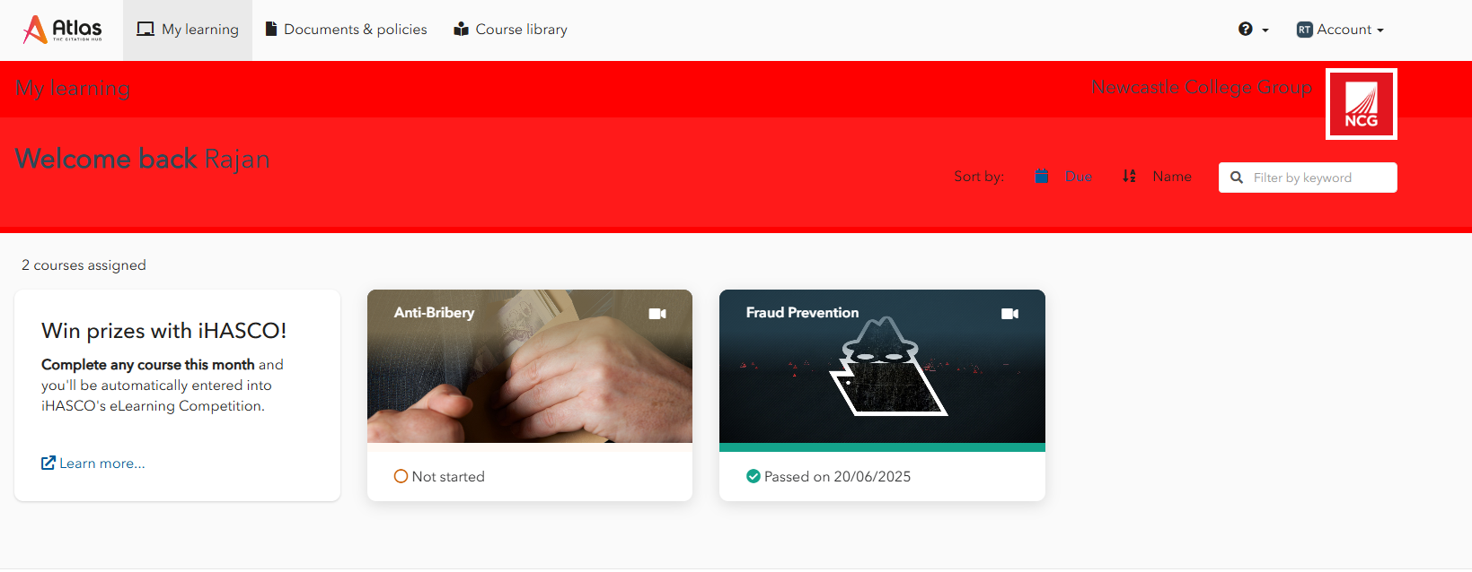

The training module will require you to watch the videos, complete a knowledge check and read the NCG Anti-Fraud Policy.
Once you have completed the training (including the knowledge check), you will be presented with a certificate to confirm you have passed the training. Please note the knowledge check must be passed to be marked as “completed” in monitoring reports.

