**NCG Process For Commencing Agency Workers**

Morgan Hunt is NCG’s preferred supplier for all temporary agency workers and permanent recruitment requiring agency assistance.

**Service Offer**

Below outlines the service offer agreed with Morgan Hunt and their supply chain:

* Dedicated account manager for NCG with support from localised support for Lewisham and Southwark Colleges.
* All temporary agency requests must be submitted via the Morgan Hunt Talent room system. Until the request has been raised in Talent room and approved by the relevant approver, Morgan Hunt will not commence sourcing candidates.
* In line with IR35 regulations hiring managers need to complete a ‘check employment status for tax (CEST)’ form, available on the [gov.uk](https://www.tax.service.gov.uk/check-employment-status-for-tax/disclaimer) website. This form will need to be completed and uploaded to the TalentRoom system when creating a requisition.Morgan Hunt will only present candidates who fully meet our pre-employment compliance checks.
* Once approved, Morgan Hunt have 48 hours (excluding bank holidays and weekends) to put forward suitable candidates who meet the NCG compliance requirements, except whereby Morgan Hunt do not have a local presence or specialism, and they will send the role straight to their supply chain. Once the supply chain has been approached, Morgan Hunt will have a further 72 hours (3 working days) to fulfil the vacancy (in totality 5 working days).
* If Morgan Hunt don’t have any suitable candidates they will go out to the agencies on their tiered supply chain depending on the role requirements e.g. agencies who have agreed to provide this service offer and the fees below.
* In the event of any urgent requirement classified as a start time for the assignment within 72 hours, Morgan Hunt will go to the supply chain after 2 working hours of receiving the vacancy, and advise if they are unable to supply within 48 hours of the vacancy being raised (excluding weekends and bank holidays). Due to the urgency, Morgan Hunt will also present candidates who may not be fully compliant outside of Talent room for consideration, and who will continue to chase compliance checks. In the event that the candidate proposed by Morgan Hunt does not have the necessary pre-employment compliance checks and is offered the role, the following checks will need to be undertaken before the assignment commences:
  + A photocopy of their ID (Passport) to evidence that they are who they so they are – please take a copy and sign it to state you’ve seen it etc
  + If no DBS within 12 months and / or there are gaps in service or missing references, a DBS Risk assessment where a candidate’s DBS is older than 12 months (risk assessment can be found in the NCG criminal records check policy) (Only applicable for agency workers and not permanent job offers)
  + A DBS declaration form (appendix 2) (Only applicable for agency workers and not permanent job offers)
* If the assignment is for longer than 2 weeks, Morgan Hunt will continue to source candidates until the vacancy is filled.
* If the same candidate is presented to us by two separate agencies, the agency who presents the candidate first with full pre-employment checks in place, should be used (even if this is outside Morgan Hunt and their supply chain).
* If you are approached by another agency offering candidates at any time, you should advise them we are under contract to Morgan Hunt, and should they wish to work with NCG, they will need to be part of the Morgan Hunt supply chain. Please pass details of the agencies interested in working with NCG to Morgan Hunt’s Account Manager, Steph Nyberg to negotiate joining their supply chain.
* If the assignment is for 2 weeks or less, and an alternative agency is used, if the assignment needs to be extended for a further short-term period of up to 4 weeks, subject to availability of the agency worker, the agency worker can continue through the alternative agency.
* If the assignment was for less than 2 weeks, and needs to be extended beyond 4 weeks, a new assignment should be raised in Talent room. Until such time as the vacancy is filled, the candidate supplied can continue, until the vacancy has been filled (but no more than 2 weeks).
* If an assignment is due to complete within 2 weeks and the candidate is required beyond this period, a new assignment should be raised in Talentroom, so that the agency worker vacancy can be approved by the appropriate approver. Hiring Managers should not make any commitment to the agency worker about any extension to their assignment, except to check that the individual may be interested in an extension. Morgan Hunt will speak to the candidate once the necessary approvals have been sought.
* If, after approaching their supply chain, there are no suitable candidates, we can consider going to other agencies outside Morgan Hunt.
* If you have used an alternate agency in the past, or used an agency worker, who you have been happy with in the past, please provide this information to the Morgan Hunt Account Manager, who will approach the agency or head hunt the agency worker to see if they are interested in providing services to NCG either as an agency worker, permanent employee, or bank staff.
* The Morgan Hunt Account Manager will then negotiate the best possible terms with the agency on behalf of NCG and ensure that candidates proposed meet the required compliance checks.
* As and when candidates finish assignments and we are happy with their performance, unless they become permanent employees, Morgan Hunt will discuss joining NCG’s Bank, so we have a pool of temporary workers available to work at short notice to fill staff timetabled shortages.
* All contact should be initiated by Morgan Hunt as no other agencies are set up on the eProcurement to be paid.
* No agency workers should be on-site without being placed by Morgan Hunt following the assignment being approved in Talentroom and Morgan Hunt instructing the agency worker to join NCG on said date and for said period. If a candidate starts work before the due process has been followed, no timesheet approval process will be in place for payment for work to be progressed. Line managers are responsible for ensuring this situation does not occur and that agency workers are paid in a timely manner for the work undertaken.
* Please note, where the process outlined in this guide is not followed, this may be managed with in line with the relevant NCG Policy.

**Current Supply Chain**

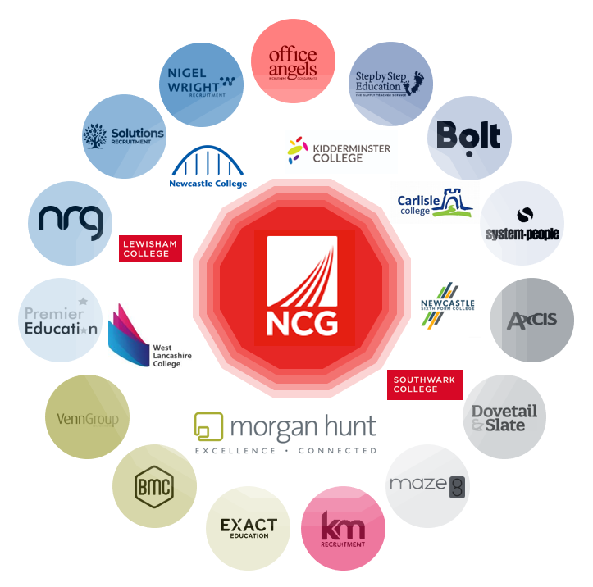

**Fees**

Below outlines the fees agreed with Morgan Hunt and their supply chain:

* Rate Card agreed for roles which may require agency workers (9% agency fee plus 12p management fee) for assignments with NCG in total of 12 weeks and under (AWR is 12.07%) and a separate Rate Card for assignments with NCG exceeding 12 weeks (AWR variable based on terms and conditions for equivalent role at the respective College). NO purchase order will be needed, as the assignment and timesheet approvals in Talent room will be used to authorise payment of the invoice.
* Transfer Fee – 10% of Contract Rate calculated for a 24-week period, with minimum charge of £1,000 plus VAT. If the contract offered is fixed term, the transfer fee is calculated pro-rata. A purchase order will need to be raised in eProcurement. The Transfer Fee Calculator can be found here:



* Finder’s Fee – 10% of salary, with minimum charge of £1,000 plus VAT. If the contract offered is fixed term, the transfer fee is calculated pro-rata. A purchase order will need to be raised in eProcurement. The Finder’s Fee Calculator can be found here:



Note: from time to time, agencies will not join part of Morgan Hunt’s supply chain due to the fees Morgan Hunt have agreed with NCG. If the agency is crucial to NCG’s success, Morgan Hunt will propose to the NCG’s Project Board the inclusion of the agency with an alternative fee structure. If accepted, these agencies will only be contacted, if no other agency within the supply chain suitable to support.

**Process to go outside preferred supplier or pay a different level of pay**

From time to time, we recognise that there may be occasions whereby, Morgan Hunt is unable to supply candidates due to:

* the preferred candidate is seeking a higher rate of pay
* no suitable candidates being available
* an alternative agency has been identified with suitable candidates BUT refuses to join Morgan Hunt’s supply chain or as a minimum put the candidate through Talent room

**Agreed process**

The process differs slightly depending on the reason for the standard process being followed, set out in the Service Offer.

1. **Different level of Pay**

If Morgan Hunt are able to provide a candidate at a higher rate of pay, the Morgan Hunt Account Manager will notify the Recruiting Manager, who will need to get approval from the local finance lead.

Once the finance lead has approved the alternative Charge Out Rate, the approval should be sent to the Morgan Hunt Account Manager, to enable them to submit candidates at the adjusted assignment details.

1. **Inability to Supply**

Where there are still no suitable candidates, or a recruitment agency refuses to join Morgan Hunt’s supply chain, a Recruiting Manager may approach other agencies in line with the process set out below.

The Recruiting Manager will need to send the following documentation to the Procurement team by email to [procurement@ncgrp.co.uk](mailto:procurement@ncgrp.co.uk):

* an email from Morgan Hunt Account Manager to confirm Morgan Hunt and their supply chain are unable to supply a candidate within the timeframes set out above in the Service Offer.
* In line with IR35 regulations hiring managers need to complete a ‘check employment status for tax (CEST)’ form, available on the [gov.uk](https://www.tax.service.gov.uk/check-employment-status-for-tax/disclaimer) website.
* a completed Waiver Form selecting option ‘4. Inability to Supply’ requesting that the supplier is re-opened on eProcurement. In the event that the supplier hasn’t been used before, a New Supplier Form will also need to be completed and submitted along with Waiver Form. The Forms are available within the [**Procurement Library**](http://intranet.ncgrp.co.uk/groupservices/Group_Contracts/Procurement/Forms/AllItems.aspx) on the intranet
* An email from the local Finance Lead containing approval to use an alternative supplier and the proposed rate from the alternate agency.
* An agency pro forma form completed by the agency (appendix 1) (Only applicable for agency workers and not permanent job offers – note the start date must not be agreed for permanent roles until NCG has undertaken all pre-employment checks)
* A photocopy of their ID (Passport) to evidence that they are who they so they are – please take a copy and sign it to state you’ve seen it etc
* A DBS Risk assessment where a candidate’s DBS is older than 12 months and / or gaps in service or missing references, (risk assessment can be found in the NCG criminal records check policy) (Only applicable for agency workers and not permanent job offers)
* A DBS declaration form (appendix 2) (Only applicable for agency workers and not permanent job offers)
* The Terms & Conditions of the recruitment agency for temporary workers and permanent recruitment, as applicable

Once submitted the Procurement team will review the information provided and forward to the relevant approver for each document to enable the offer to be made:

* DBS Risk Assessment to the Director of People and Development for approval.
* Terms and Conditions to the Contracts team to ensure NCG’s liability is acceptable. If the liability is higher than they would expect, express approval from the Finance Lead for the College will be sought.
* Waiver Form to the Head of Contracts & Procurement for approval, unless the due process has not been followed, and then this will need to be approved by the Chief Finance Officer.

Once the use of the alternative agency has been approved, the Procurement team will open the supplier account in eProcurement, so a Purchase Order (see notes below) can be raised by the Recruiting Manager and send to Employee Operations the following documents in order to keep a record:

* DBS Risk Assessment (where appropriate)
* DBS declaration form (where appropriate)
* Agency Pro-Forma

**Use of Purchase Orders**

Purchase Orders are only required for agency workers whereby the timesheets are not approved in Talent room and for all Transfer and Finder’s Fees.

1. **Agency Workers outside of Morgan Hunt**

All Purchase Orders must be raised prior to the assignment commencing as QUANTITY orders and for the full duration of the assignment and clearly state:

* Job role
* Location
* Assignment length including start and end date
* That the assignment is a one-time assignment
* The number of hours authorised along with the charge out rate. You should also ensure that you agree prior to the appointment the transfer fee should the candidate apply and be successful for a permanent role with NCG within 6 months’ of leaving their assignment.

The Recruiting Manager will need to receipt the Purchase Order weekly once the timesheet has been approved to ensure timely payment of invoices.

Please note, for candidates through Morgan Hunt and Talent room once the timesheet is approved in Talent toom, the invoice will automatically be paid by Accounts Payable by the due date. Therefore, please ensure you check the timesheet before approving.

1. **All Transfer and Finder’s Fees**

The NCG Recruitment Process should be followed for all permanent recruitment. If you intend to use an agency as part of the recruitment, you must specify within the requisition in Networx. You must only approach Morgan Hunt to support with the recruitment initially. If Morgan Hunt are unable to source suitable candidates, the same process to go outside the preferred supplier for agency workers should be followed, with the exception pre-employment checks, which will be undertaken by the Recruitment team once the offer is raised in Networx.

If a candidate subsequently joins NCG as a permanent employee at the end of the recruitment process, and a transfer fee is payable to Morgan Hunt or an alternative agency, a Purchase Order must be raised for the appointment in eProcurement before the individual starts their employment with us.

If you are using an alternative agency to Morgan Hunt and their supply chain, you should ensure you negotiate the transfer or finder’s fee before any offer is made to the candidate or the agency worker joins NCG for their initial assignment.

Transfer and Finder’s Fees can range from 8% to in some cases 40% of salary, so it is crucial that Finance Leads are aware of these before approving the offer. Where possible, these fees should be as close as possible to the Morgan Hunt agreed rate of 10%.

**Pre-Employment compliance requirements**

The Recruiting Manager will need to ensure that the agency is compliant with NCG requirements in regards to employment checks including DBS, Home Office and references and that such checks have taken place prior to the candidate being presented to us.

**Appendix 1: Agency Pro-Forma**

**To be completed by the Recruiting Manager prior to the worker commencing any assignment.**

A copy of this form along with written confirmation from the agency that pre-employment checks have been completed and verified should be sent to [employeeoperations@ncgrp.co.uk](mailto:employeeoperations@ncgrp.co.uk).

This documentation will be used to monitor that pre-employment checks are carried out on agency staff in line with NCG and KCSIE standards.

|  |  |
| --- | --- |
| **Name of Approved Agency Used** | |
|  | |
| **Pre-employment check** |  |
| Date of engagement |  |
| End Date |  |
| Full Name |  |
| Date Of Birth |  |
| NI Number |  |
| Job Role |  |
| Confirmation from agency that qualification checks undertaken (including Teacher Reference Number if applicable) |  |
| Confirmation from agency that identity check completed |  |
| Confirmation from agency that right to work in UK check completed |  |
| Confirmation from agency that satisfactory references received |  |
| Confirmation from agency that employment history check undertaken |  |
| Confirmation that enhanced DBS Disclosure obtained |  |
| Confirmation that barred list check obtained (If applicable) |  |
| Date of DBS Disclosure |  |
| Disclosure Number |  |
| Recruiting Manager |  |
| College |  |

***All agency workers must present ID verification on their first day***

**Appendix 2: DBS Status Declaration Form**

Section 1: Colleague Details

|  |  |
| --- | --- |
| Colleague Name |  |
| Department |  |
| Line Manager |  |
| College |  |

Section 2: Current / Most recent DBS information

|  |  |
| --- | --- |
| DBS Certificate Number |  |
| DBS Date |  |
| Undertaken by |  |

Section 3: Declaration

I can confirm there have been no changes to my DBS since it was last completed (please tick appropriate response)

Yes

No

|  |
| --- |
| If no, please confirm changes: |

Please note, if it is found that you have not disclosed all relevant information or have not been truthful in your declaration, this may result in NCG terminating the contract.

|  |  |
| --- | --- |
| Signature |  |
| Date |  |